Jeet Kumar October 2, 2024
Lab 15: Network Traffic Analysis
1. (2 pts.) What is the IP address of the web server? 172.17.0.1
2. (2 pts.) What is the user agent of the client connecting to the web server? Mozilla/5.0
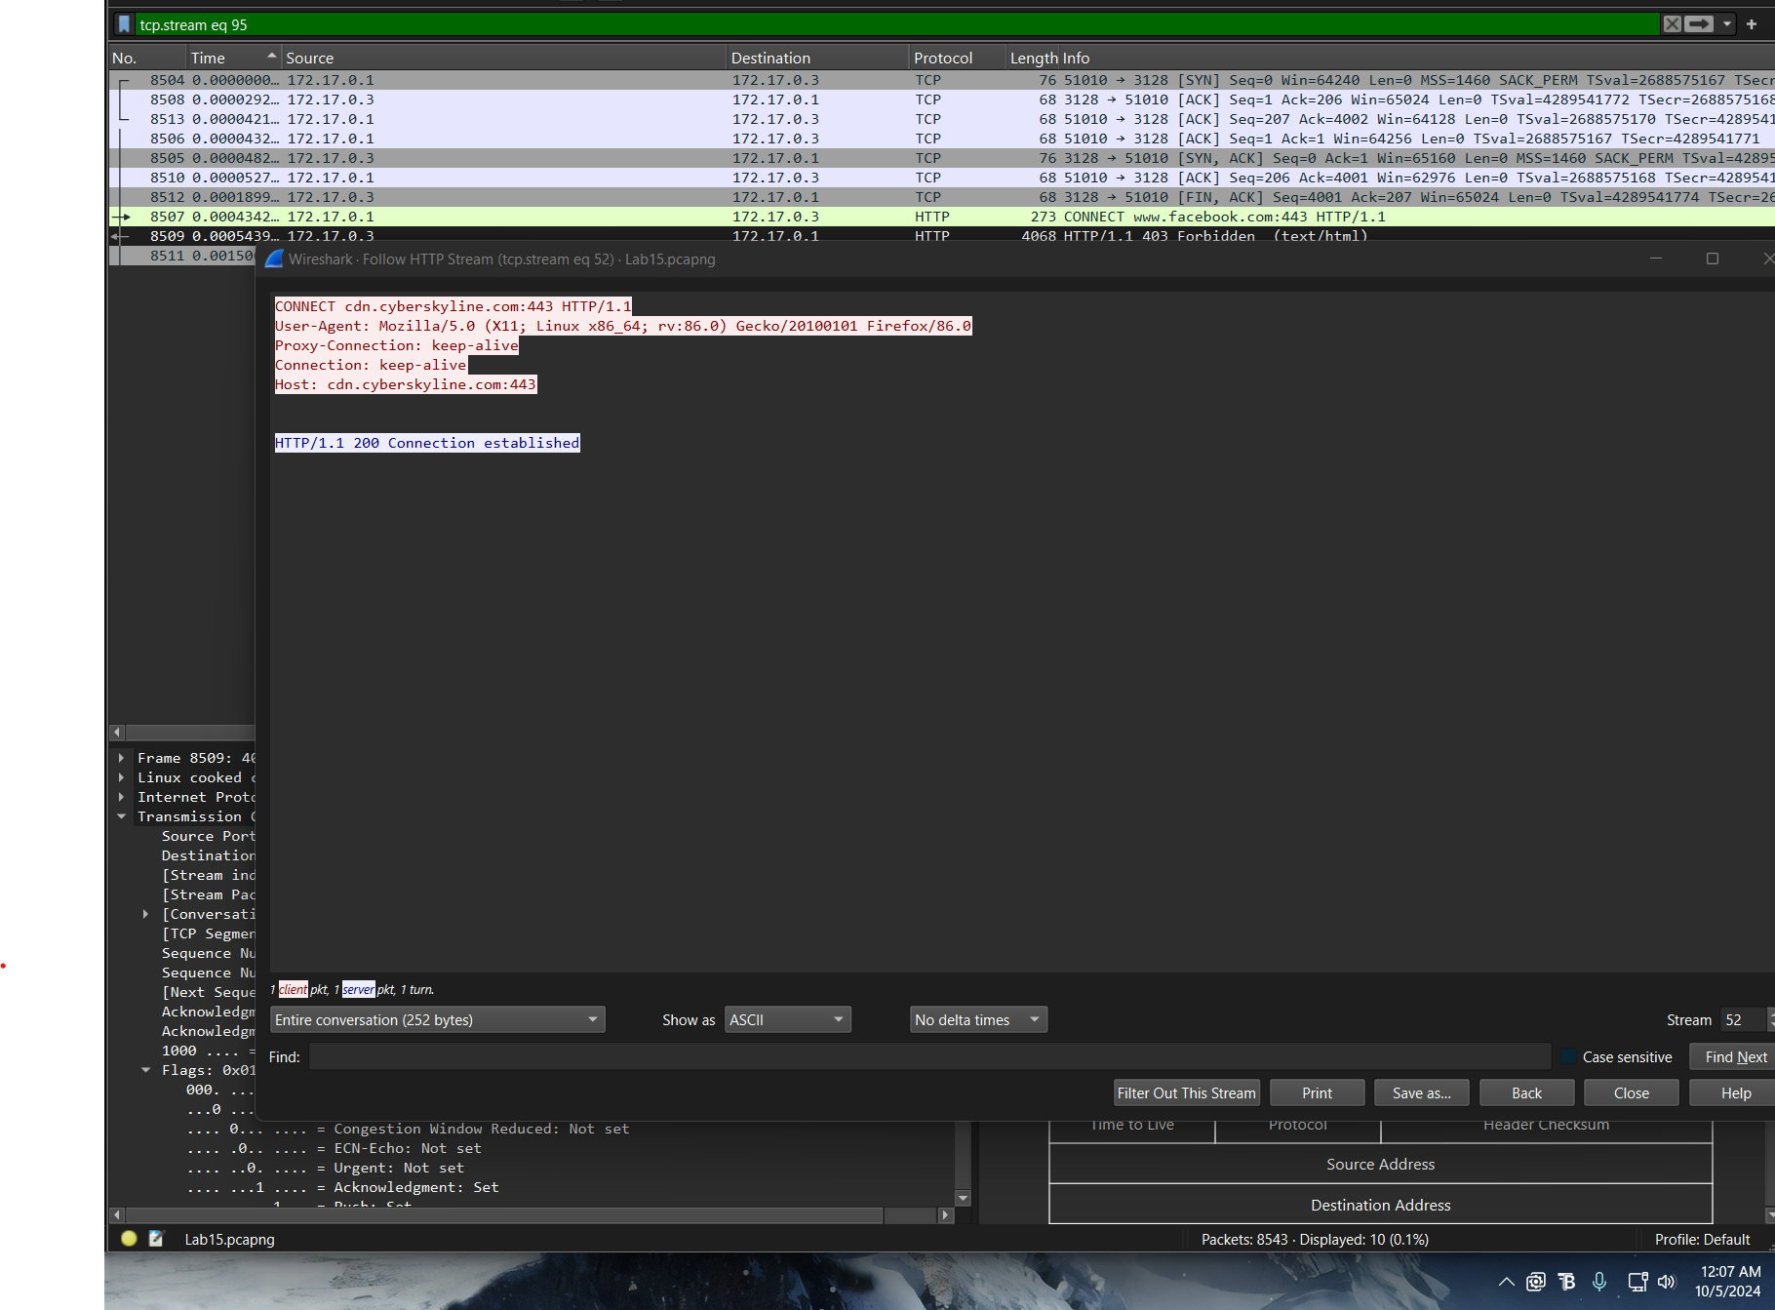
3. (4 pts.) What is the name and version number of the web software that serves the proxy configuration? Gecko/20100101
4. (2 pts.) What is the IP address of the proxy? 172.17.0.3
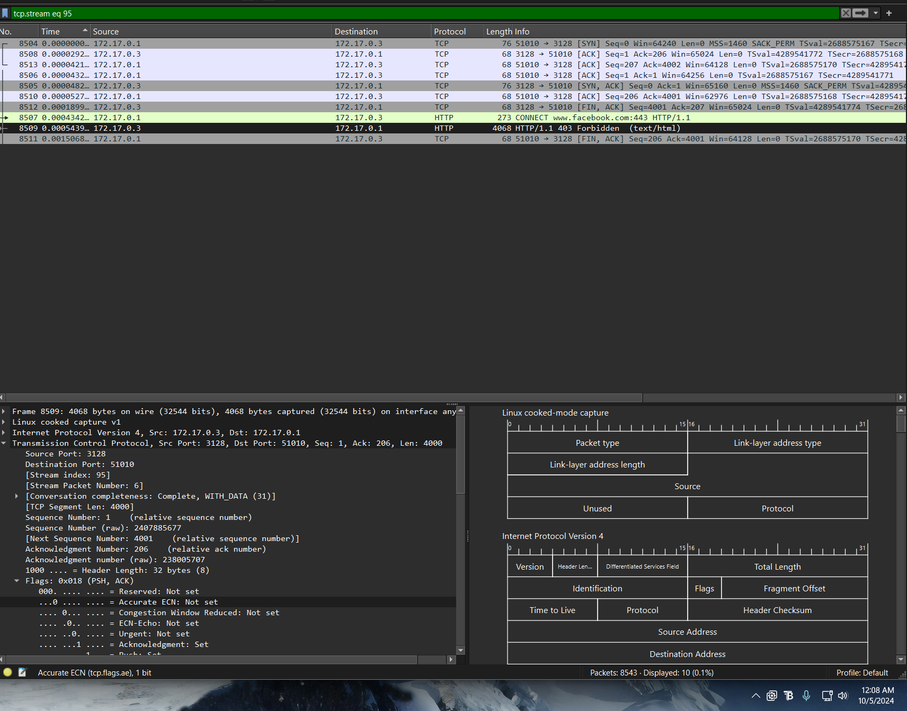
5. (2 pts.) What port number is the proxy listening on? 3128
6. (4 pts.) What is the name and version number of the proxy software being used? Squid 4.6
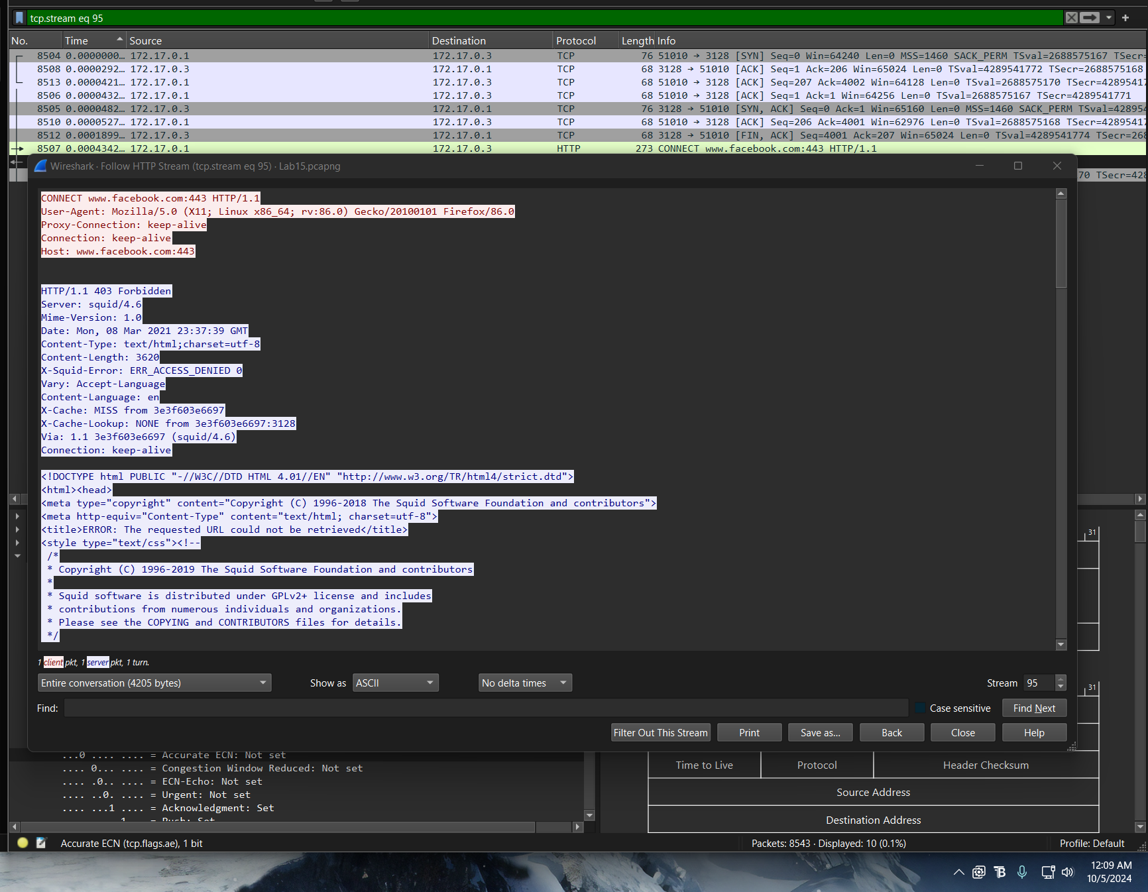

7. (4 pts.) What domain name is the proxy blocking? How do you know this? Explain your answer.
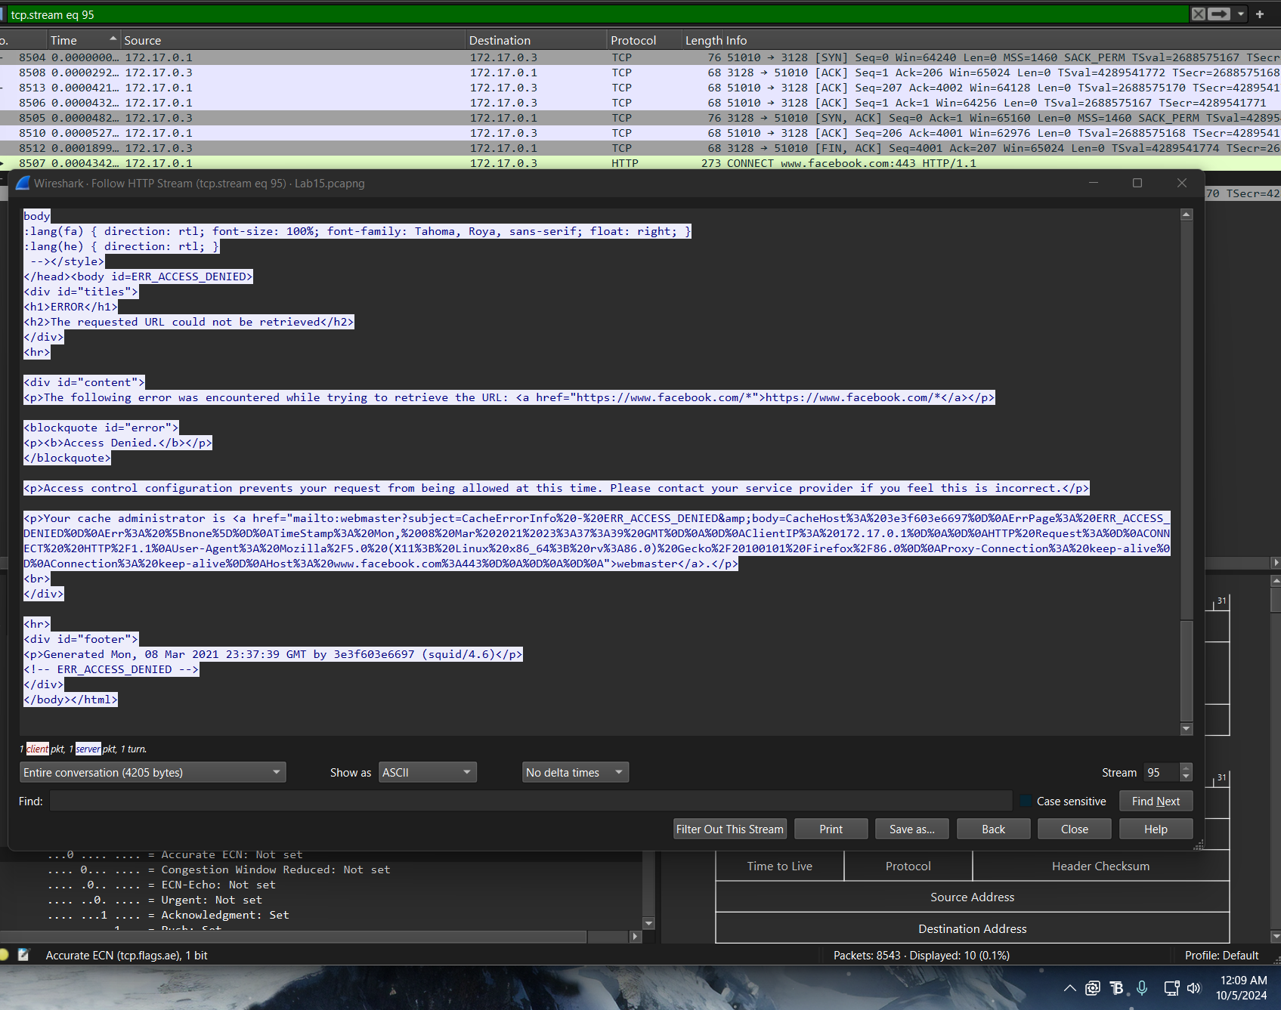
Facebook.com is the domain name the proxy is blocking because this packet is showing up with a forbidden notice. This is mostly due to a security issue found in the packet by the proxy server and by following the HTTP stream, we can see that there is this domain in the packet in access control message.

